"Microcontrollers Explained: Build a Legal WiFi Detector with ESP32" What is a Microcontroller?
1. Definition
A microcontroller is a small computer built into a single integrated circuit (chip). It contains:
- A processor (CPU)
- Memory (RAM and Flash)
- Input/Output (I/O) pins
- Communication modules (WiFi, Bluetooth, UART, etc.)
Unlike a desktop computer, a microcontroller is designed to control specific tasks inside electronic systems.
Examples used in this module:
- ESP32 (by Espressif Systems)
- M5Stack Core (ESP32-based development kit by M5Stack)
2. What Does a Microcontroller Do?
A microcontroller:
- Reads inputs (buttons, sensors, WiFi signals)
- Processes data using programmed instructions
- Controls outputs (LEDs, screens, motors) In this project:
- The ESP32 scans WiFi networks
- It counts detected networks • It turns on:
o Green LED (Normal) o Yellow LED (Caution) o Red LED (Alert)
It is acting as a decision-making controller
- Microcontroller vs Microprocessor
Feature Microcontroller | Microprocessor
Purpose Embedded control | General computing
Memory Built-in | External required
Example ESP32 | Laptop CPU
Used in IoT devices, robotics PCs, servers Microcontrollers are used in:
  - Washing machines
  - Cars
  - Smart TVs
  - Medical devices
  - IoT systems
- Internal Components of ESP32 The ESP32 contains:
  - Dual-core processor
  - WiFi module
  - Bluetooth module
  - GPIO pins (General Purpose Input Output)
  - ADC (Analog to Digital Converter)
  - Flash memory
This makes it ideal for:
  - Wireless detection
  - Sensor monitoring
  - Smart automation
- Why ESP32 is Used in This Project We use the ESP32 because:
  - It has built-in WiFi
  - It supports scanning nearby networks
  - It can control LEDs
  - It is affordable and educational
  - It supports programming in Arduino IDE Most importantly:
It performs PASSIVE detection only. It does NOT transmit interference.
- Step-by-Step: How the Microcontroller Works in This Project
  - Power is supplied through USB.
  - The program starts running.
  - WiFi scan begins.
  - Number of networks is counted.
  - Conditional logic checks thresholds.
  - LED color output is activated.
  - Process repeats every 5 seconds.
This is called a control loop.
- Teaching Explanation (Instructor Notes) When explaining to students:
  - Compare a microcontroller to a “tiny brain” of a device.
  - Explain that it follows instructions written in code.
  - Emphasize embedded systems concept.
  - Reinforce that detection is legal, jamming is illegal.

Student Module

Wireless Interference Detection Project
- LEGAL NOTICE – DETECTION ONLY: This module describes a wireless interference
DETECTION
- system. It does NOT transmit signals and MUST NOT be modified into a jammer. Jamming • communications is illegal in most countries and may result in severe penalties.

What You Will Learn
- How WiFi scanning detects nearby networks.
- Difference between detection and illegal jamming.
- How LEDs/LCD provide status feedback.

Color Meaning
- GREEN Normal wireless environment
- YELLOW Caution – increased signal activity
- RED Alert – strong interference detected
Lab Activity
- Measure signal levels in 3 different locations.
- Record number of networks detected. • Explain why results differ.

Worksheet Questions
- Why is wireless jamming illegal?
- What does GREEN indicate?
- What environment produced RED? Why?

ExperimentActivity
🔧 Step-By-Step Build Procedure (Student Instructions)
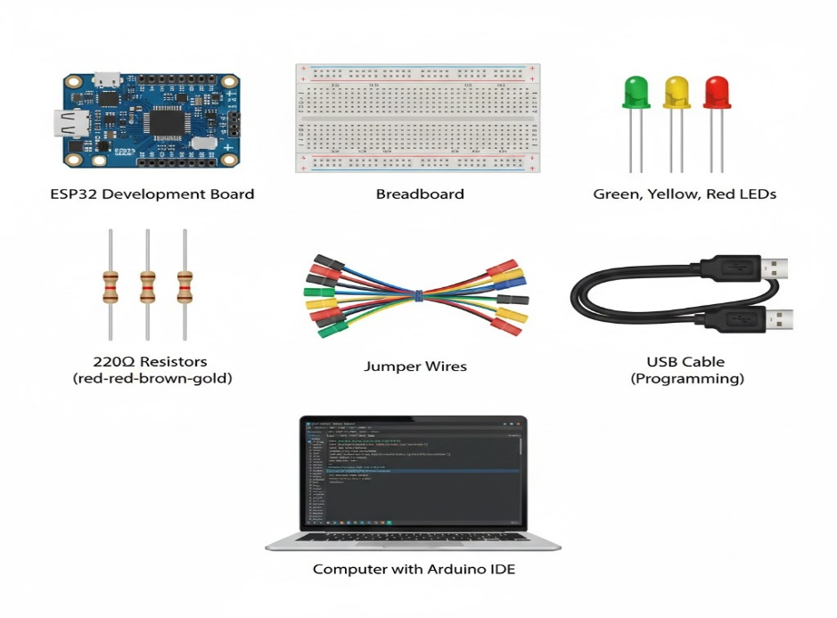
Before You Start
Make sure you have the following materials:
• ESP32 development board
• Breadboard
• 3 LEDs (Green, Yellow, Red)
• 3 × 220Ω resistors
• Jumper wires
• USB cable
• Computer with Arduino IDE installed

Step 1 – Insert the ESP32 into the Breadboard
- Place the ESP32 across the center gap of the breadboard.
- Make sure both rows of pins are accessible.
- Do NOT connect USB power yet.
Step 2 – Connect the GREEN LED (GPIO 25)
- Insert the long leg (anode) of the green LED into the breadboard.
- Insert the short leg (cathode) into a different row.
- Connect:
• GPIO 25 → one end of a 220Ω resistor
• Other end of resistor → long leg of green LED
• Short leg of green LED → GND pin on ESP32
The green LED represents NORMAL condition.
Step 3 – Connect the YELLOW LED (GPIO 26)
- Insert the yellow LED into the breadboard.
- Connect:
• GPIO 26 → 220Ω resistor → long leg of yellow LED
• Short leg → GND
The yellow LED represents CAUTION condition.
Step 4 – Connect the RED LED (GPIO 27)
Insert the red LED into the breadboard.
Connect:
• GPIO 27 → 220Ω resistor → long leg of red LED
• Short leg → GND
The red LED represents ALERT condition. Step 5 – Check All Connections
Before powering the board:
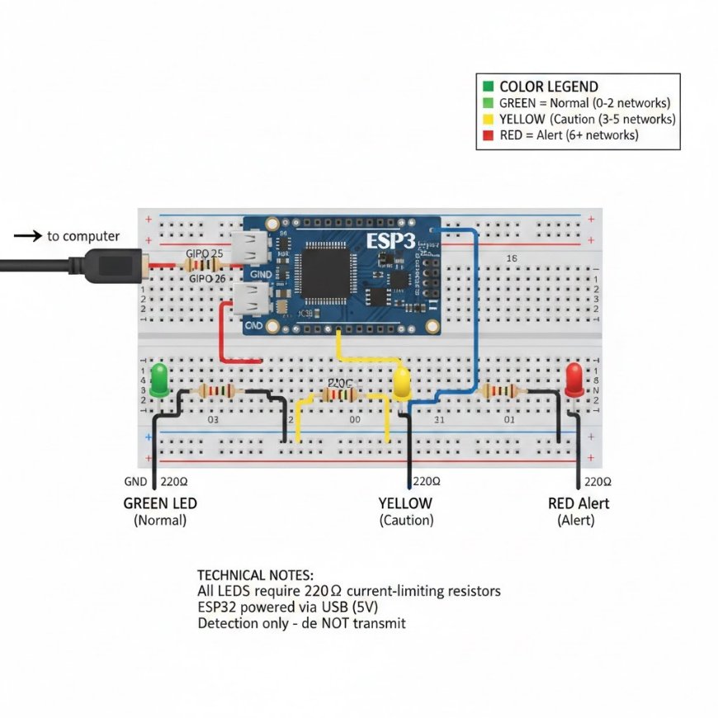
• Each LED must have its own 220Ω resistor
• All short LED legs must go to GND
• No wires should touch incorrectly
• Verify GPIO numbers are correct
This prevents short circuits and damage.
Step 6 – Connect and Power the ESP32
- Connect the ESP32 to your computer using USB.
- Wait for the computer to detect the device.
Step 7 – Configure Arduino IDE
- Open Arduino IDE.
- Go to Tools → Board → Select “ESP32 Dev Module”.
- Go to Tools → Port → Select the correct COM port.
- Paste the provided code into the editor.
Step 8 – Upload the Program
- Click Upload.
- If upload fails:
• Hold the BOOT button while clicking Upload.
• Release when uploading begins.
Wait until “Done Uploading” appears.
Step 9 – Test the System
- Open Serial Monitor.
- Set baud rate to 115200.
- Observe the number of WiFi networks detected.
- Observe which LED turns on.
Move to different locations to compare results.
code
#include <WiFi.h>
int G = 25;
int Y = 26;
int R = 27;

void setup() {
Serial.begin(115200);
pinMode(G, OUTPUT);
pinMode(Y, OUTPUT);
pinMode(R, OUTPUT);

WiFi.mode(WIFI_STA);
WiFi.disconnect();
delay(100);
}

void loop() {
Serial.println("Scanning...");
int n = WiFi.scanNetworks();

Serial.print("Networks detected: ");
Serial.println(n);

if (n > 5) {
digitalWrite(R, HIGH);
digitalWrite(Y, LOW);
digitalWrite(G, LOW);
}
else if (n > 2) {
digitalWrite(Y, HIGH);
digitalWrite(R, LOW);
digitalWrite(G, LOW);
}
else {
digitalWrite(G, HIGH);
digitalWrite(R, LOW);
digitalWrite(Y, LOW);
}

delay(5000);
}

